**ASSIGNMENT - 21.1**

**Problem Statement:**

Write a mapreduce program to use CombineFileInputFormat. Pass a directory containing multiple small files. The program should be able to pick multiple files in a single mapper.

**Input:**

We have four input files named a1, a2, a3 & a4 in directory ass21.1 as below:

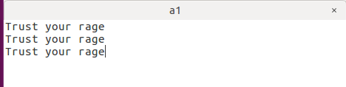

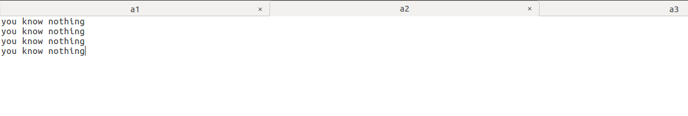

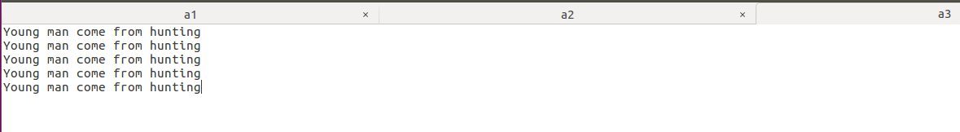

**C:\Users\612906\Desktop\21(1,3)&amb\a4.png**

**Program:**

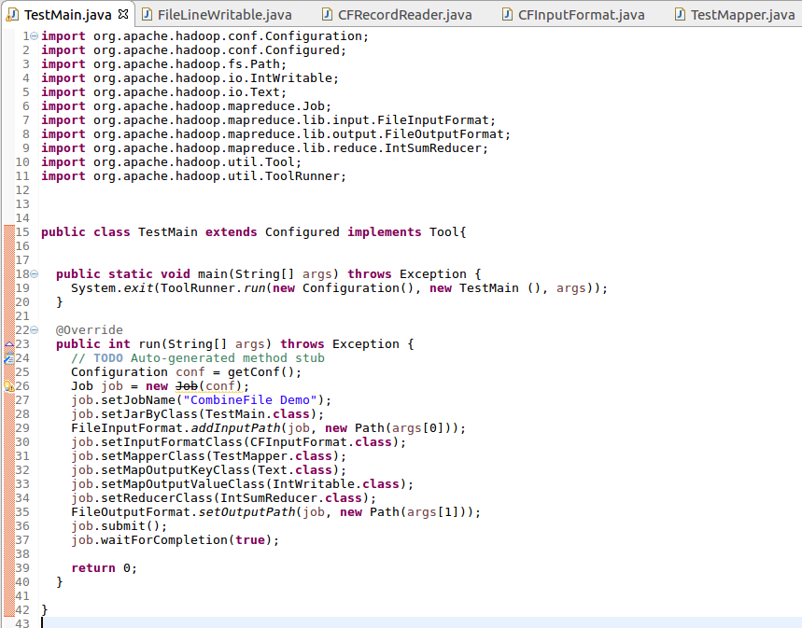

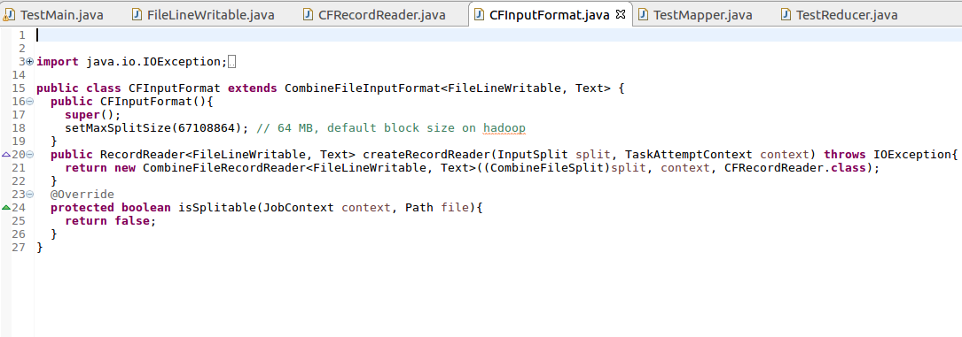

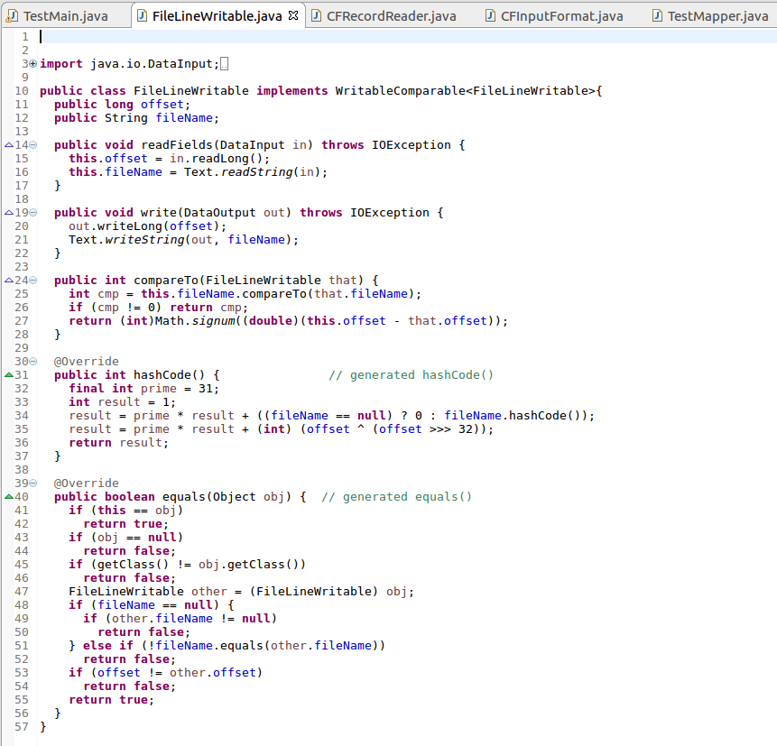

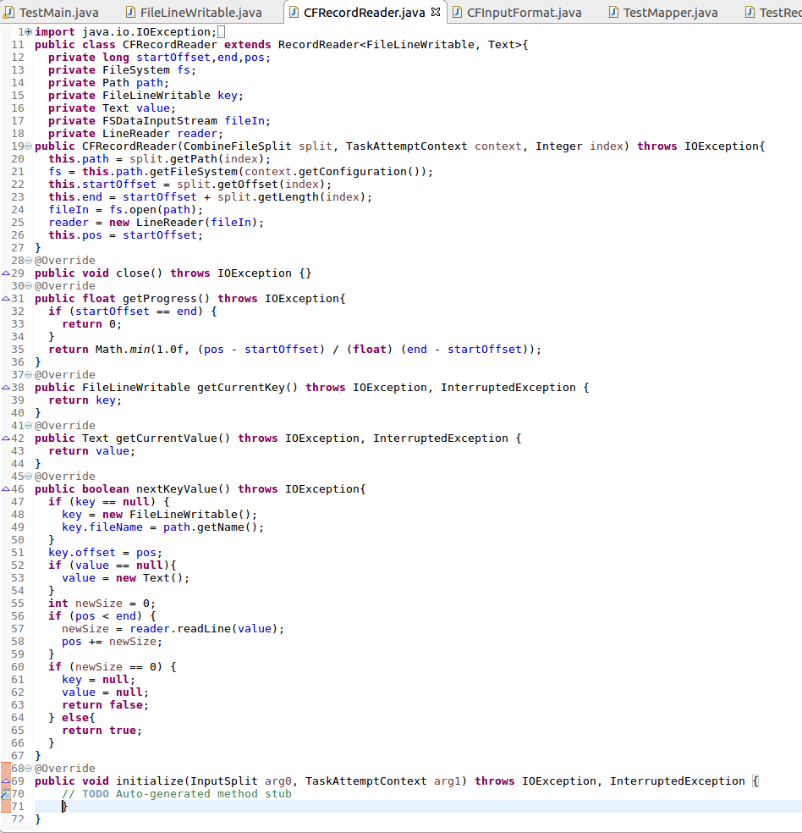

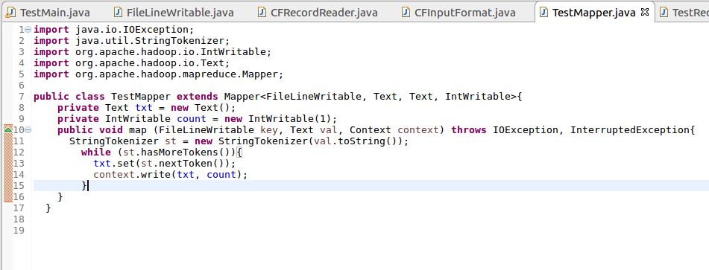

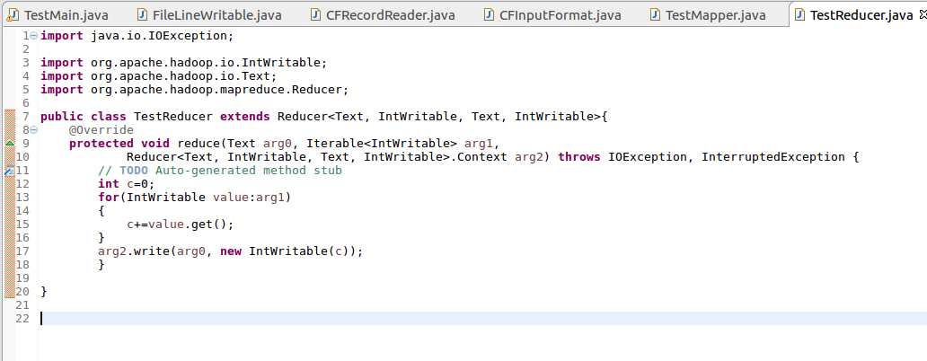

**Output:**

